# Assignment 7

# Acceptance Testing

## Deadline: See separate specification

## Roles involved

* Process Owner: Mrs. Mira Kajko-Mattsson
* Industrial advisor: Mr.Stefan Britts
* Process Executors
  + External Consultant: Mr. Bengt Koren
  + No-fee Financial Advisor: Mr. Bengt Koren
  + Practitioners: IV 1300 Students

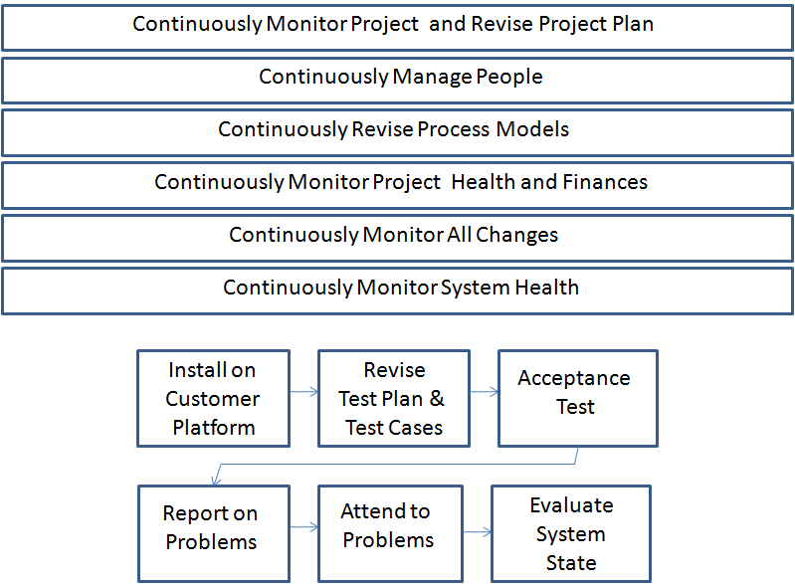

## Process

In this phase, it is expected that the whole system is ready with system testing. Now, it is now the customer who tests the system. Before doing it however, he will have to have the system installed on his platform.

Overall, in this phase, you repeat the steps of the system testing phase. However, you adapt them to the acceptance testing context. Below, I suggest the steps for the *Acceptance Testing*  phase. These steps may or may not occur in sequence or in parallel.

1. Revise Acceptance Test Plan and Test Cases
   1. As usual, always before starting any testing activity, you, as a customer now, will have to revise your test plans and test cases and make changes if required.
2. Test and Regression Test
   1. Using the test cases, you as a customer, test the system. You are also allowed to test in an ad hoc manner implying that you do not follow any test plan and cases. Such tests may be useful and here you may spontaneously encounter problems. When doing it, I advise you to record or videofilm the testing process. This is because it is easy to forget how you have arrived at a specific problem. It may be difficult for you to recreate the problem. Ad hoc testing should correspond to no more than 10% of the overall testing effort.
3. Report on Problems
   1. You, as a customer, are obliged to report on all the problems to the supplier. Use the formal problem reporting process and make sure that you use a problem report template for describing the problems.
4. Attend to Problems
   1. You, as a developer, are obliged to attend to all the problems that have been reported to you by the customer. Deliver your solutions as soon as possible. Before delivering them make sure that your new solution does not cause any integration problems. SOME PROBLEMS MAY BE DIFFICULT TO ATTEND TO. THEY MAY BE TOO EXPENSIVE. IN THIS CASE YOU AND PROJECT MANAGER ARE OBLIGED TO REPORT ON THIS TO THE ADVISORY BOARD AND WAIT FOR THEIR DECISION WHETHER TO ATTEND TO THE PROBLEM OR NOT. OF COURSE, CUSTOMER MUST BE INVOLVED IN IT.
5. Evaluate System State
   1. You, as a tester, project manager, product manager and most importantly, as a customer, must continuously evaluate the state of the system. Is it ready for moving to the next phase, the *deployment* phase, or is it not?
6. Revise Project Plan
   1. You as a project manager, will have to continue to revise your project plans. During acceptance testing, many unexpected problems may be encountered. Here, you have the opportunity to evaluate your former versions of the project plan and make adjustments for the future.
7. Continuously Manage People
   1. You, as a project manager, will have to continuously monitor the atmosphere within the project and look for problems..
8. Continuously revise your process models
   1. Your process models will never be optimal. Now, when you have stepped into the acceptance testing phase, you have the opportunity to evaluate your process model and make adjustments for the future.
9. Continously monitor project health and finances
   1. You, in your role as a project manager and test manager, will have to continously monitor the testing process. You look for problems, identify new risks, monitor the already identified risks and report them to product owner or other management. Here, it is very important to monitor risks and their impact. Please remember you are soon ready with the whole work. You cannot afford unexpected surprises.
   2. You, in your role of an architect and designer, will have to continuously monitor whether the architecture and design are followed when making the last minute changes to the system.
   3. You, as a measurement manager, will have to measure the testing process and continuously report on the measument results. One of the important measurements is the number of problems reported by the testers so far.
   4. You, as a marketing and finance manager, will have to check whether the project exceeds the planned budget, and if so, then take approprite measures.
   5. You as a business manager and analyst will have to be receptive to all the customer and developer input and take actions, if necessary. During acceptance testing, you will have to be very careful to accept any changes to the system. In some cases, however, you will have to do it anyway.
   6. You, as an accetance tester, will have to continuously check and revise your accpetance test plans and test cases. Especially important is it to monitor all the changes to the requirements. This automatically implies changes to the test plans and test cases.
   7. You, as a documentation manager, must make sure that everybody documents what is requested from them to document. If changes need to be made to the problem reporting template, then you take appropriate measures.
   8. You, as a configuration manager, make sure that everbody follows version and configuration management rules.
10. Continuosly monitor system health
    1. You, as a quality manager, should continuously check the quality of the system. Pls observe that all the effort you have put into the system quality may be in vain when developers do quick and dirty changes in the stressful acceptance testing phase.

**Please remember that all test problems must be managed via a problem reporting process. All of them must be documented. Nothing should be communicated orally! Even the problems discovered during the ad hoc testing. Also, all changes should be documented.**

1. Continuously provide feedack to your customer
   1. Here, you may report on the testing status.

## Phase 7 Deliverables

The assignement will result in the following deliverables:

* *The whole system that has been accptance tested. Deliver all system code*
* *Deliver all acceptance test cases and test results.*
* *All problems and changes that have been reported, their solutions and the decisions made behind them.*
* *All problem reports following your organizatonal template*
* *All the minutes of the meetings, if any.*
* *A specification of all the changes made to your processes*
* *Effort required for the acceptance testing phase in the BCPM.* The effort should be provided for each task and individual practitioner/student and it should compile the results for the whole company.
* *The company’s expenditures so far to be delivered by Financial Mananger.*
* *Experience gained during this phase.* Here, you list problems, good sides of the BCPM process phase, important decisions made and motivations behind the decisions.
* *All the documentation is delivered to Bilda “Phase 7 Deliverables”.*